**CASE REPORT:**

A 51-year-old white female, with a previous history of controlled hypertension, and no other relevant personal or family pathological history; presents with an painless insidious onset of blurred vision described as a "haze" in both eyes, with progressive worsening of visual acuity, markedly after 9 months of onset, when she described visual dimming, leading to a leave of absence from work. The patient did not present any other neurological or systemic symptoms. She underwent several evaluations with ophthalmologists, without any diagnosis or specific treatment, and ophthalmological causes were ruled out, including retinopathies. She was then referred for neurological evaluation in a tertiary hospital one year after the onset of symptoms. In the initial evaluation, funduscopy examination revealed bilateral optic atrophy, notably on the right eye, without retinal abnormalities; and visual acuity measurement of Light Perception (LP) in both eyes, with no other noteworthy findings on physical examination (a complete neurologic examination with an assessment of sensorium, cranial nerves, motor function, sensory, coordination, gait, reflexes, meningeal irritation, and long tract signs was performed with no relevant findings). The cognitive evaluation was also normal.

During hospitalization, an extensive diagnostic investigation was performed, with orbital MRI (Magnetic Resonance Imaging) demonstrating signal change in the left optic nerve pathway, suggestive of optic neuritis without signs of recent inflammatory activity (no contrast enhancement)**;** brain and cervical and thoracic spine MRI (Magnetic resonance imaging) with no significant changes; optical coherence tomography (OCT) showed a bilateral reduction in the peripapillary retinal nerve fibers layers (RNFL). The main laboratory findings included positive type II oligoclonal bands (OCBs) in the cerebrospinal fluid, with normal cell, protein and glucose count. She underwent several laboratory tests (infectious disease serology, rheumatology panel, vitamin serum levels, antiAQP4 and antiMOG investigation), with negative results. Therefore, the patient presented a severe, bilateral and painless atypical optic neuropathy, and several diagnostic hypotheses were raised, including demyelinating, infectious, metabolic, toxic, nutritional and hereditary causes, which were ruled out after initial investigation. Patient underwent empirical pulse steroid therapy with methylprednilosone 1g/day for seven days, with no clinical response. She was discharged from the hospital for further outpatient investigation.

During this period, a careful review of medical records and exams was carried out, and a slight change was detected in the brain MRI, with a signal change in the right hippocampus, suggestive of hippocampal sclerosis. This finding raised again the hypothesis of an immune-mediated, and possibly paraneoplastic, clinical condition. An Onconeural Antibody Testing was then requested, and a positive anti-amphiphysin antibody result changed the entire course of the investigation. This antibody is strongly associated with paraneoplastic syndromes, and after an intensive literature review, we found a Chinese article with a case series (in total seven cases) of atypical bilateral optic neuritis associated with antineuronal antibodies (three of them with positive anti-amphiphysin), and all cases associated with underlying malignancy.

The patient was hospitalized again, undergoing new tests for neoplastic screening (thorax and abdomen tomography, oncotic cytology, transvaginal ultrasound, thyroid ultrasound, and upper gastrointestinal endoscopy) with no alteration in these tests. We proceed with mammography and breast ultrasound, and a lump was detected in the left breast with a prominent axillary lymph node on the right, classified as BI-RADS 4 category with indication for biopsy. In this hospitalization, pulse steroid therapy with methylprednisolone 1g/day was performed again for five days, and later seven plasmapheresis (plasma exchange) sessions, with a slight improvement in visual acuity measurement, going from bilateral Light Perception (LP) to bilateral Hand Movement (HM), and stabilization of the progression of visual impairment.

In the biopsy result, it was detected an invasive ductal carcinoma of no special type (NST) with estrogen and progesterone receptor-positive (receptor-positive breast cancer). She also underwent PET-CT (Positron emission tomography) with the finding of right axillary lymph node enlargement, of an undetermined nature. The lymph node was also biopsied, with a finding of infiltration by carcinoma. Thus, the patient was classified as stage T1N0M1. She was referred for evaluation with Oncology and Mastology department, and treatment with tamoxifen was started, which was later suspended and anastrozole and goserelin were introduced.

She is currently undergoing treatment for breast cancer, and remains in outpatient follow-up in the Neuroimmunology department, maintaining stability of visual acuity, and without new neurological complaints.

**REFERENCES:**

Xu, Q., Du, W., Zhou, H., Zhang, X., Liu, H., Song, H., Wang, X., & Wei, S. (2019). Distinct clinical characteristics of paraneoplastic optic neuropathy. *The British journal of ophthalmology*, *103*(6), 797–801. https://doi.org/10.1136/bjophthalmol-2018-312046

**IMAGES:**

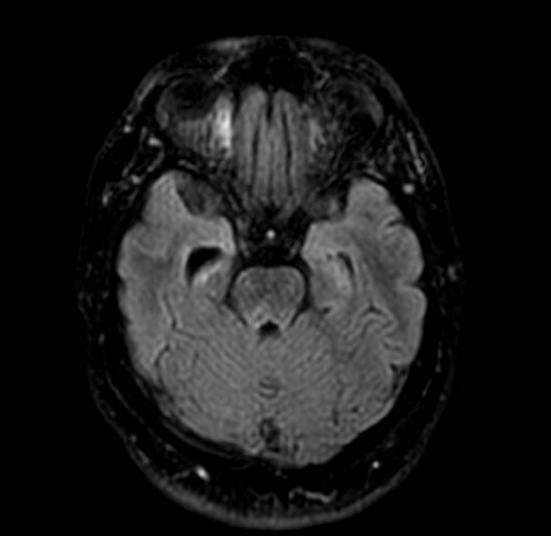

**Image 1:** Axial T1-weighted MRI with right hippocampal sclerosis

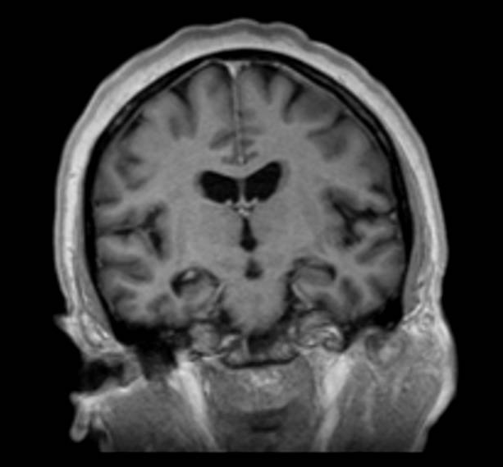

**Image 2:** Coronal T1-weighted MRI with right hippocampal sclerosis

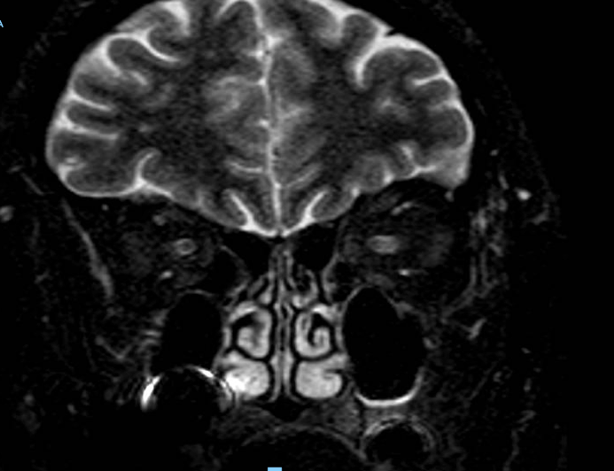

.

**Image 3:** Coronal T2-weighted MRI with signal change on the left optic nerve